AUTHOR / SCHOOL | PATRIZIA RUSSO / LICEO A. MANZONI – CASERTA- ITALY
DATE OF CLIL ACTIVITY | April 2016
CLASS / NUMBER OF STUDENTS | First year of high school. 14 year old students- 20 students
SUBJECT | LATIN CULTURE
CLIL LANGUAGE | ENGLISH
CLIL Activity Topic | Aesop and his fables
CLIL Activity Time | 180‘
Language Objectives | Improving writing, reading and speaking skills  Telling about past events with a focus on the description of characters and their positive and negative traits
Language used for communication (BICS) | Time connectors  Simple past  Future in the past  Personality adjectives
Content Language (CALP) | Telling an original fable modelling Aesop’s ones.
Content Objectives | Students will know about:  - Aesop and Phaedrus, their fables concerning style and morals  -the structure and main traits featuring their fables  Promotion of critical thinking
Materials / Resources used | Web tools: WIKI for online cooperation, HotPotatoes for cloze, PowerPoint for final projects, Wordle for the topic presentation, Edmodo for projects submission and evaluation.  Resources: YouTube, Britannica online, dedicated websites.
CLIL Activity - procedure | LESSON 1- The fable: structure and features 60’  - Warm-up - 10 minutes  The students are asked to consider the Wordle shown on the Interactive whiteboard and tell the teacher what they are going to learn about. They have also to give reasons for their opinion.  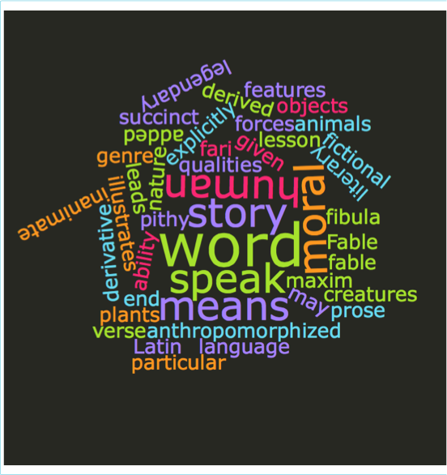  - Reading activity-15 minutes- Cloze Exercise  This is a definition of FABLE, fill in the missing words choosing from the list at the bottom of the page  The (1)__________________ fable is (2)__________________ from a Latin word “fibula” which means a (3)__________________ that is a derivative of a word “fari” which means to (4)__________________. The Fable is a literary (5)__________________: a succinct (6)__________________ story, in prose or (7)__________________, that features animals, legendary (8)__________________, plants, inanimate objects, or forces of (9)__________________ that are (10)__________________ (given human qualities, such as the ability to speak human (11)__________________) and that illustrates or (12)__________________ to a particular moral lesson (a "moral"), which (13)__________________ at the end be added explicitly as a pithy maxim.  A)Latin word B)speak C)nature D)genre E)fictional F)derived G)anthropomorphized H)creatures I)verse L)leads M)language N)may O)word  ----------Key----------  JCloze Exercise  The word fable is derived from a Latin word “fibula” which means a story that is a derivative of a word “fari” which means to speak. The Fable is a literary genre: a succinct fictional story, in prose or verse, that features animals, legendary creatures, plants, inanimate objects, or forces of nature that are anthropomorphized (given human qualities, such as the ability to speak human language) and that illustrates or leads to a particular moral lesson (a "moral"), which may at the end be added explicitly as a pithy maxim.  - Reading activity 15 minutes.  These are the parts that make a fable up and the corresponding definitions, They are in a scrambled order, match them in the proper way.  Critical Vocabulary Words and Definitions  - Reading activity and Class discussion for the checking of results -20 minutes  Work in couples, read the two listed fables and identify the several parts they are made up of. - The fox and the grapes - The wolf and the lamb  http://aesopfables.com  - Homework: read the fable “The lion, the fox and the wolf” and summarize it. Upload the summaries on Edmodo virtual class.  The teacher will check the summaries at home giving individual evaluations and hints for improvement in the virtual class.  LESSON 2- Aesop and Phaedrus: lives 60‘  - Warm-up - class discussion - groups of 4 students-10 minutes, checking included  Who was Aesop and why did he write fables with animals as characters? Who was Phaedrus and what did he write?  - Listening activity- Aesop: Biography of a Great Thinker- YouTube video 15 minutes, class checking included.  Scaffolding. The teacher illustrates the aim of the activity:  Watch, listen and concentrate on the following points - Where he lived and when - what his social position was - his aspect - authors that mentioned him in their works  https://www.youtube.com/watch?v=ZjkzXpRxBQM 2.29‘  - Reading activity – Phaedrus, Roman Fabulist- 15 minutes, class checking included.  Read the text from the "ENCICLOPEDIA BRITANNICA" and focus on the following points - Where he lived and when - what his social position was - reasons why he was proud of his work - authors that mentioned him in their works  https://www.britannica.com/biography/Phaedrus-Roman-fabulist  - Reading fables looking for: - characters and their positive and negative qualities. - positive and negative behaviours 20 minutes + homework  The teacher divides the class in 4 groups and gives each group 3 different fables to consider. The fables are taken from the following list  - The City Mouse and the Country Mouse  - The Fox and the Crow  - The Tortoise and the Hare  - The Lion's Share  - The Wolf and the Crane  - Sour Grapes  - The Wind and The Sun  - The Lion and the Mouse  - The Peacock's Complaint  - Two Men and the Bear  The students will have to use their own mobiles to connect to the WIKI page created by the teacher in order to fill in the WIKI table with adjectives that define the characters and their behaviours. If class time is not enough, The students can finish at home. They can use the attached list of adjectives  A collection of Aesop's fables  http://www.storyit.com/Classics/Stories/aesop.htm  Scaffolding: list of personality adjectives http://www.esolcourses.com/content/exercises/grammar/adjectives/personality/words-for-describing-personality.html  WIKI table  https://aesopcharactersandtheirqualities.wikispaces.com/Aesop%27s+characters+and+their+qualities  LESON 3 Characters analysis – fable phases revision- modelling 60’  - Homework checking and teacher’s considerations -10 minutes  The teacher focuses on the wiki filled in by the students highlights strong and week points, adds his own adjectives giving reasons why  - Characters analysis and moral message -15 minutes  The teacher arranges the students into the same groups than the previous lesson  Working instructions: consider the connections among actions, qualities and their consequences for each of the several fables you have read.  Work out a list of positive and negative behaviours and moral values.  Identify for each fable the several phases.  - Groups report to class- 20 minutes  - Eventual class discussion and teacher’ s revision of the various acquisitions 15 minutes
  FABLE: a fictitious story or tale, intended to instruct some useful truth or to amuse‬
  1) exposition: � | A) the part of a story which occurs after the climax and sets the tone for the new way that things will be from now on‬
  2) conflict: � | B) a lesson that is taught through a fictitious story‬
  3) resolution: � | C) the presentation of essential information in a story, such as characters and setting‬
  4) moral: � | D) occurs when a character is opposed by some character or force‬
Performance Assessment | The students will have to invent a fable, in the Aesop’s style, providing information about the characters’ qualities and a final moral teaching. They will have to write and illustrate it using PowerPoint. They will upload it on their virtual class, Edmodo) for sharing and evaluation  RUBRIC FOR MULTIMEDIA PROJECT EVALUATION – webtool: Rubistar  https://www.dropbox.com/s/3ayd5runp47aj8w/Powerpoint%20Appearance%20and%20Content%20%3A%20Project%20and%20multimedia%20RUBRIC.pdf?dl=0
Cultural Aspect(s) | Different morals for different societies and cultures.

APPENDIX
Final projects
https://www.dropbox.com/sh/q1hpmd7uk8oxl8t/AADZPEQnvAzVW5GMoyGj_WHRa?dl=0

https://www.dropbox.com/s/7e1kgrxztb4hnx8/Cocky%20the%20Lion%20M%20Krogh.mp4?dl=0

